Relics of Kotar: The Eye of Kotar
One of the three relics of Kotar. Attuning with this artifact bestows upon the user incredibly vivid visions of either the past or present - but even the shortest of moment’s use comes at high cost.

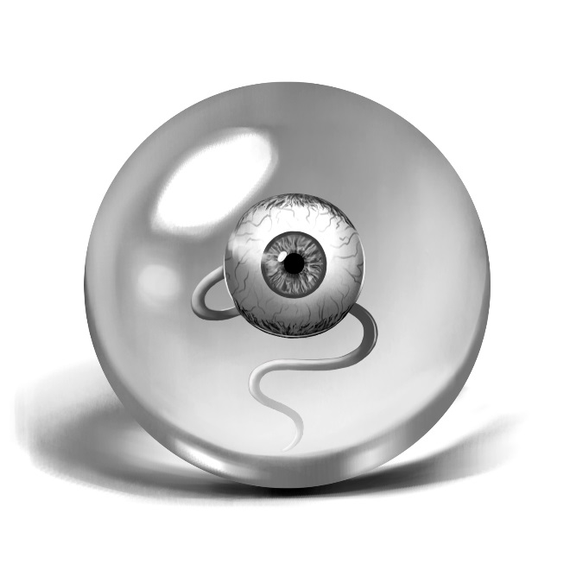
Appearance
A small crystal sphere a few inches across. Inside is a human eyeball, bloodshot, with a pale blue iris. It twitches slightly as it looks around, and when it meets someone’s eyes, there is intelligence and will in its gaze.

Magnitude
Area: 6 (a city block)
Duration: 1 (a few minutes)
Quality: 3 (Excellent)
Cost: 5 stress to activate. Lasts for one minute, and costs 3 stress for every minute thereafter. Whoever possesses this relic can see into any location within one mile of their location. They do not need to have been in this location before; they simply need to know it exists. It allows only sig\ht, not hearing. The user must hold the eye in their hand the entire time.

